Design principles
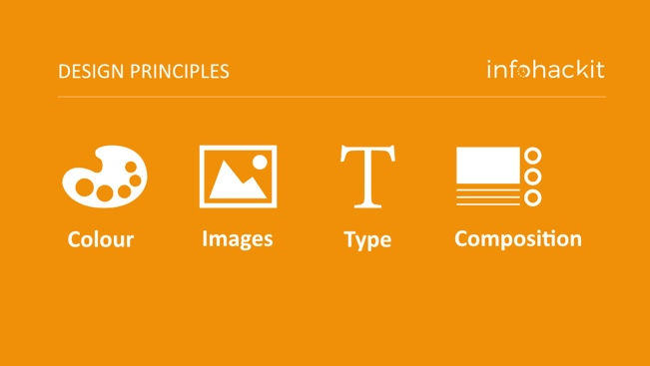

Being a designer is a little like running NASA mission control. There are lots of things to think about, often at the same time, and lots of knobs, sliders, buttons to work with. These design principles will help you understand the control you have over your design work, and how to improve your knowledge, skills and decision-making processes.

Colour
Colour systems
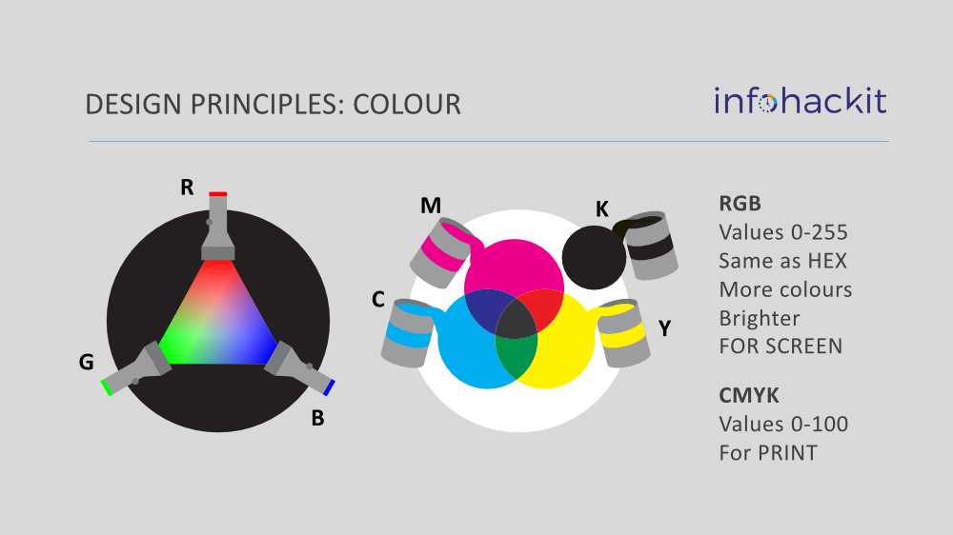
Name | Colours | Application | Higher values means…
RGB | Red, Green and Blue | Digital displays eg. computers, phones etc | Lighter colours
CMYK | Cyan, Magenta, Yellow and Black | Print eg posters, journals etc | Darker colours

Hex codes
On the web, colours are often expressed using a hex code. This is just another way of expressing RGB. The code often starts with a # symbol, followed by 6 characters with values from 0-F. These characters operate in pairs, the first two corresponding with red, the second pair green and the third blue.
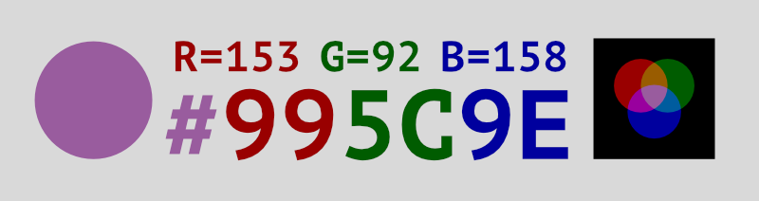
Conversion
Conversion from CMYK to RGB tends to work well. I recommend starting with CMYK in your documents, even if you plan to output graphics in RGB later.
Conversion from RGB to CMYK can be more problematic. There are a lot of colours in RGB that cannot be reproduced in CMYK, bright blues and greens can look very different.
Pantone
Pantone is a colour matching system used in printing. It can be useful if:
You are printing documents in two colours (eg. black and one other colour) - this can be a cost effective print solution for leaflets or reports
You are designing something for screen printing processes, eg. mugs, badges, t-shirts.
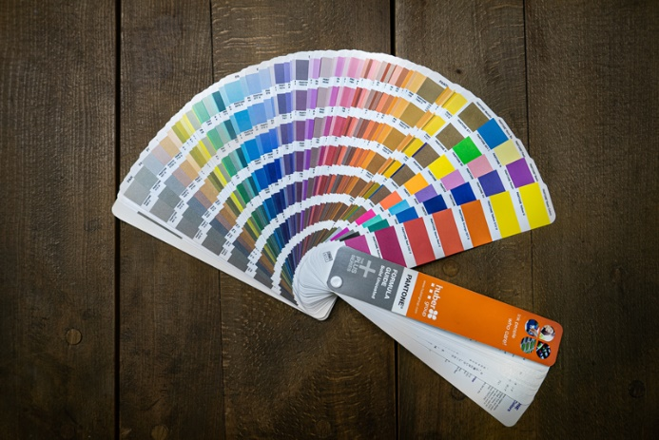

Images
Raster images
Raster images are made of pixels. Each pixel is a tiny dot in the image, which has a colour reference. Raster images are very useful for photographic images.
Raster images all have a size and resolution which affects their quality.
Vector images
Vector images are made of mathematical curves. Instead of pixels, the file defines shapes and their size, coordinates, colours etc.
Unlike rasters, vector images can be reproduced at any size without losing quality.
Vectors are very useful for logos, infographics and figures.
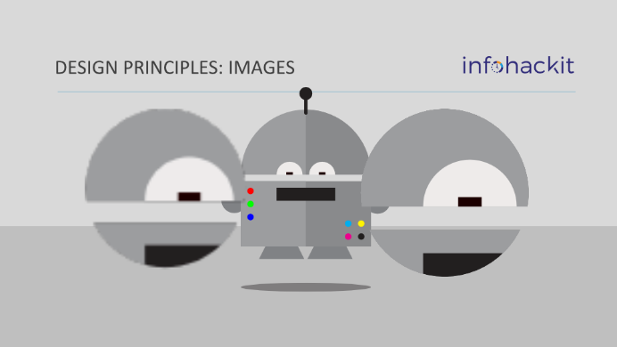
Vector software
A lot of software is capable of supporting vectors. In our workshops we use Affinity, but you can also use Adobe Illustrator or Inkscape.
Microsoft Office applications also support vector graphics. Any text created in Word or PowerPoint is a vector. Any of the drawing tools in these applications will also create vector shapes.
File types
File types | Raster or vector | Transparency | Proprietorial | Notes
.jpg | Raster | NO | NO | compression can cause visual problems
.tif | Raster | NO | NO | high quality, records every pixel
.png | Raster | YES | NO | good quality compression
.gif | Raster | YES | NO | can hold multiple image frames for animation
.afdesign | Vector | YES | YES (Affinity) | can support rasters too
.ai | Vector | YES | YES (Adobe) | can support rasters too
.svg | Vector | YES | NO | Supported by HTML5, so very useful for web
.pdf | Vector | YES | NO | Can support multiple pages, and support rasters
This table is by no means exhaustive! There are many other file formats.
You will notice that vector files CAN support rasters too. It doesn't make them a vector, but they can be stored in a vector file. This does not work the other way around. If you copy a vector into a raster file, it will become rasterised.
Resolution
Resolution is one important piece of information that helps us judge the quality of an image and its suitability for display.
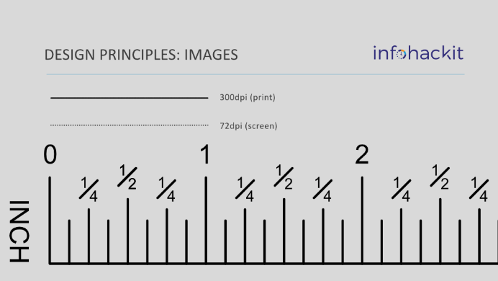
Resolution is measured in DPI
(dots per inch).
This represents the number of dots along
a single inch, 1 dot (or pixel) high.
Resolution for most screens is 72dpi.
Resolution for print is 300dpi.

Image quality
Resolution is important, but we can't look at it in isolation.
We should also consider:
- The size of the image
- The intended scale of the image in layout
- Therefore what the effective resolution is (300dpi image at 200% scale = 150dpi)
- The physical context - for example, a research poster is usually viewed at a metre or so away. From that distance, image quality is less important.
- The design context - how important is that image to the overall design? For example, the cover of a university prospectus is VERY important. An image supporting the description of a degree programme, one of several on a page, is less important.
- The source and creation of the image. A photograph taken outside on a sunny day with a good camera will look sharp, a photo taken by a cheap smart phone in poor lighting will not.
Importantly, TEST your images if you are not confident that they are good enough.
Raster editing software (eg.Paint.net or Adobe Photoshop will help you review the size and resolution of your image.
Type
By “type”, we mean text, characters, words, typography, fonts, lettering etc
Serif and Sans Serif fonts
Choosing the right font for your design work is important. Often, the first choice to be made is serif or sans serif.
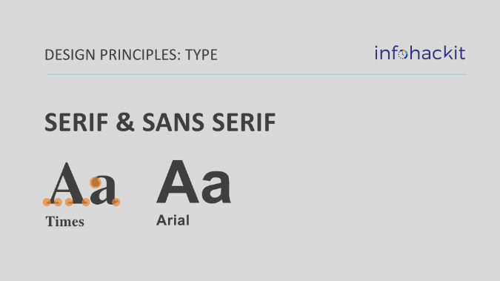
A serif font has small lines attached to various parts of the letter.
A classic example is Times New Roman.
A sans serif font is simply a font without serifs.

Choosing between them can be hard, and they can work nicely together, often with a serif font for headings and a sans serif font like Arial or Helvetica for the main body of text.
There are discussions as to which type of font is easier to read.
Further reading: Serif fonts and legibility
Font families
In design software, we're given access to font families. These are variations on a standard font, and are extremely useful for creating differentiation between design elements, without having to use different fonts to do it.
In Microsoft Office, if we want to make something bold, we usually use CTRL-B, or the 'b' button. In design software we substitute the font for a bold version instead. This gives the design greater stability, and reduces risk of text reflows.
Google fonts indicates the number of 'styles' available in each of their fonts. You can download the whole family.
Montserrat, for example, has 18 fonts in its family

Typesetting
Effective typesetting will make your designs easier to read and understand. Some factors to consider:
Factor | Notes
Font size | Designers often use font sizes that are smaller than word processing conventions, because good typesetting makes smaller fonts more legible. A good font size choice must be relative to the design context and audience. Sometimes, it's advisable to reduce font size to accommodate better paragraph and line spacing.
Line spacing / leading | Measured (often in pts) from baseline to baseline. Line spacing should generally be larger than the font size (a good guide is +5pt to +10pt).
Paragraph spacing | In word processing, we often use a double return to separate paragraphs. In design, we control the space between the paragraphs precisely. Good practice depends on the context. If space is tight, a first line ident can be considered instead of spaces between the paragraphs. It's a good idea to reduce the paragraph spacing for bullet points to about half of your regular paragraphs.
Character spacing / tracking / kerning | Over extending and excessively reducing the character spacing can make text harder to read. Note that over extending character spacing can occur when using justification. Reducing character spacing slightly can help fit text into neater paragraphs (perhaps when one word is alone on a line)
Justification | Is it better to justify both sides of the text? People have very different opinions about this! Try both ways and see which works best with your text – but be consistent throughout your design

Consider these two examples of typesetting, and see what differences you can see between them.
If you prefer one side to the other, then ask yourself “why?”.
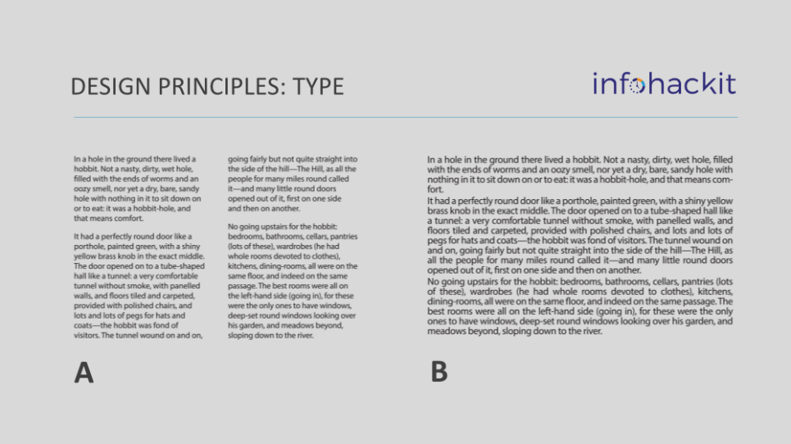
Composition
Composition is where we bring our colours, type and images together to make layouts. Remember: you are in control and making good decisions!
Concepts
The following concepts are a good way to start thinking about successful composition. They will help you begin an iterative process that starts once you have most of your content on the page, and ends with a professional looking design!
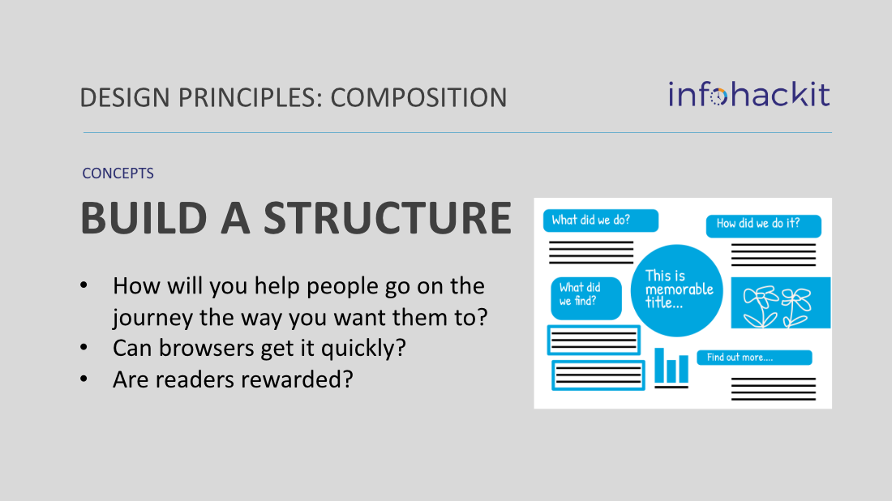

Poster Hacks
What makes a poster look professional, approachable, and easy to understand?
You can have an amazing creative visual, or the perfect word count and font size, but good design is the combination of lots of things. My poster hacks are some of the most useful things I’ve discovered over the years, and will have a quick and positive impact on your poster.
They are a mixture of subjective and objective points to consider, so not a set of rules! Remember, you are in control and making good choices.
Before I list the 10 hacks for better poster design, I’m going to tell you about the three most important letters for poster design: MGP. Margins, gutters and padding.
Margins – the space around the outside of your poster. This isn’t like a margin in Word, you can extend your backgrounds and images to the edge of your poster. This margin is where your content starts and ends.
Gutters – the space in between major objects. The example below has two different gutter sizes, but you can just use one.
Padding – the space inside of boxes. This is the most under used of the three.
When you are designing your poster, pick one measurement for your margins, another for your gutters and one for your padding. It’s not so important what the measurement is, because this depends on the needs of your content, and the size of your paper. Generally, I use them in descending order – M > G > P.
It’s most important to be consistent.

In Europe and America, we read from the left, so there is a visual expectation that the place to start reading will be at the top left of your poster.
The other benefit of left aligning your poster title is that it’s more space efficient and gives logos a defined position, rather than splitting them either side.

Word and PowerPoint tend to automatically put lines around shapes. This can give your design work a cluttered look. My advice is either have a line, or a colour fill. Keep it simple.

PowerPoint doesn’t offer the ability to type a value for corner radius. So you have to do it by eye. Design software allows us to specifiy precise consistent values.
Never let your corner radius exceed the padding of your box, it will make the text or image content look very tight and cluttered.

There are so many fonts available, it’s tempting to use a lot of them. You don’t need many. Choose a font which has a few different options (if your fonts are limited, you can download new ones from google fonts. https://fonts.google.com

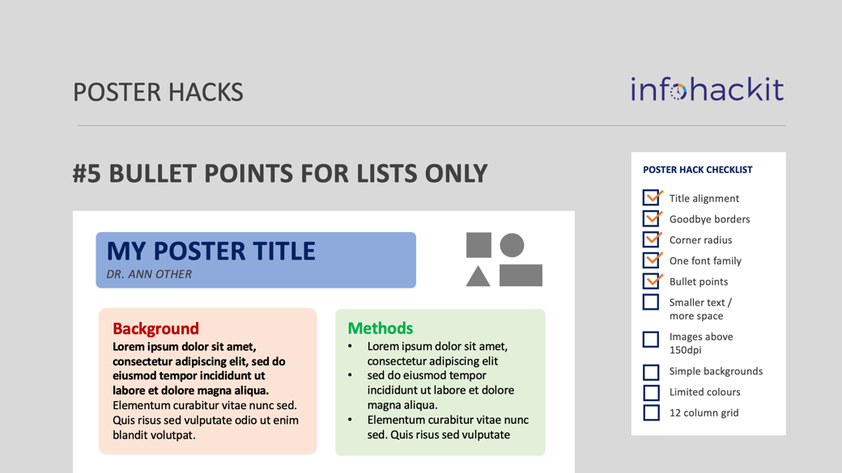

Bullet points are perhaps the most overused design element. I’ve seen several posters where ALL of the text was presented in bullet points, even the title!
Like all text formatting, bullet points can be used for emphasis, especially when presenting a list.
Here’s a few other basic types of text formatting which you can use to create structure and hierarchy in your poster typesetting:
Regular text | Bold text
Italic text | Underlined text
CAPITAL LETTERS | Highlighted text
Coloured text | Different sizes

If you ask someone how to improve the legibility of your text, they will often say ‘make it bigger’.
However, reducing the font size can often afford you more space for line spacing, paragraph spacing etc and make your text more approachable and easy to read.

Image resolution can’t be ignored! Raster images like jpegs and gifs will start to look pixelated the larger they get.
If you can, use vector images. Most data vis platforms allow you to export as vector.

Complex backgrounds on posters can be very distracting and reduce legibility. Photos are possible of course, but you need to give careful consideration to how you lay your content over the top. I’ve seen posters with photographic backgrounds you can barely see.
Better still, you can use simple shapes and icons to create more abstract backgrounds, that will still make your poster look great. Shape tools in PowerPoiint are vector.

Colour is a very useful principle of design. I very often start my designs with very simple colour palettes, and then use colour to create emphasis and meaning.

Designers use 12 column grids because 12 has lots of factors. You can use a 12 column grid to divide a poster in half, thirds, quarters, sixths and combinations.

